**Assignment 17.3**

Problem Statement

Write a mapreduce job that takes configuration from command line (min.word.count). Based on the configuration, it should perform count of words from a document and produce only those words in the output whose count is greater than or equal to the configuration.

Driver Class:

In Driver class we are making it the extends configured class and implementing tool interface and tool runner static method run which creates a configuration object before the run method.

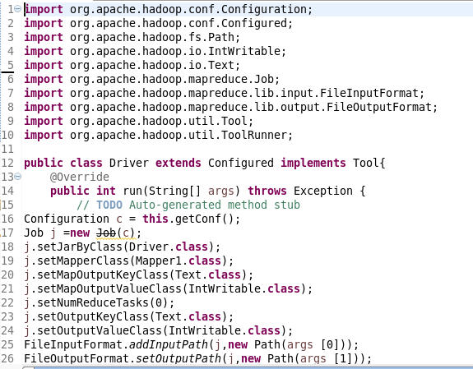

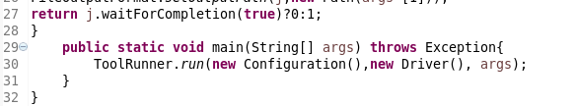

Mapper Class:

In Mapper, I am using hashmap and if hashmap contains the word the count will be incremented or else a count of 1 will be made.Words will be counted only if the occurrence of word is greater than or equal to the given value

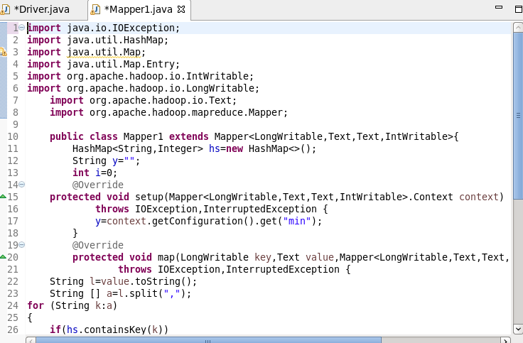

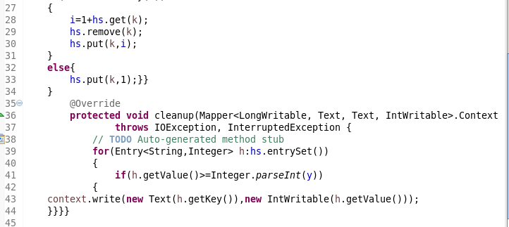

Running jar :

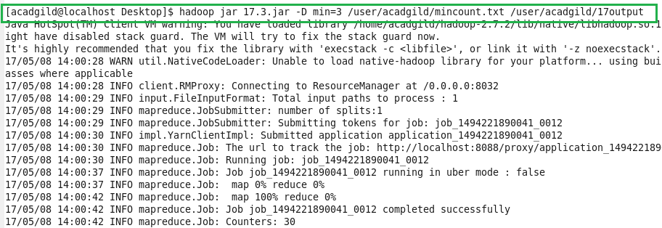

Input :

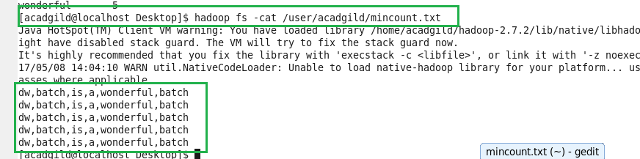

Output:

